PREVENT DUTY POLICY

ST. PATRICK’S INTERNATIONAL COLLEGE

PUBLICATION DATE: OCTOBER 2018

REVIEW DATE: SEPTEMBER 2019
- St Patrick’s International College’s Prevent Policy has been informed by both the Office for Student’s guidance and the Governments Prevent Duty Guidance for Higher Education Institutions in England and Wales. This policy sits within St Patrick’s International College’s Safeguarding framework and this policy should therefore be read in conjunction with the Safeguarding Policy. This policy describes the College’s contribution to the multi-agency Prevent agenda and defines the College’s process for referral.

Introduction

- St Patrick’s International College (the College) is committed both to protecting freedom of speech and academic freedom and to preventing people from being drawn into terrorism.

  - Prevent is one part of the Government’s strategy to target the threat of terrorism
and extremism.

2.2 Channel is a multidisciplinary programme which focuses on providing support at an early stage to people who are identified as being vulnerable to being drawn into terrorism.

St. Patrick’s College promotes adults and young people in making positive choices about their lives and endorses the Channel early intervention scheme for students who could be at risk of radicalisation. The non-statutory guidance can be found here

http://course.ncalt.com/Channel_General_Awareness/01/index.html

2.2. This policy outlines the College’s commitment to preventing people from being drawn into terrorism. In doing so we recognise that terrorism can be associated with a range of ideologies. A definition of terrorism is provided in Section 3 below.

2.3. This policy is written with reference to the Counter-Terrorism and Security Act 2015, the Equality Act 2010, the Human Rights Act 1998, the Data Protection Act 2018, and the Freedom of Information Act 2000. The Counter-Terrorism and Security Act 2015 places a duty on Universities to have ‘due regard to the need to prevent people from being drawn into terrorism.’ The Act also notes that Universities must seek to balance this duty with their commitment to freedom of speech and the importance of academic freedom.

2.4. The College has taken a risk-based approach in discharging its duties under the Counter-Terrorism and Security Act 2015.

Definitions

- People are defined as staff, students and visitors. For the purposes of this policy:

3.1 A student is defined as anyone who has accepted a place at the College, is currently studying at the College or who has completed their period of study but has outstanding assessments.

3.2 A member of staff is defined as anyone who has accepted an offer of employment, or who is currently employed.

3.3 Visitors is taken to mean temporary members of staff, contractors, individuals working in a voluntary capacity with staff or students and anyone involved in an activity taking place on College premises in their own right or on behalf of an organisation that has been given permission to use College premises.

- Terrorism is defined as the use or threatened use of violence for the purpose of advancing a political, religious, racial or ideological cause.

- Principal means the person with primary responsibility for the management of a campus, or his/her nominee; or for students enrolled onto an online programme of study, the director or other person with overall responsibility for the delivery of the programme concerned, or his/her nominee

Responsibility for this policy

- Ultimate responsibility for the development of clear and effective processes and procedures associated with the maintenance of standards and quality assurance of academic provision and overseeing their application lies with the College’s Executive Board.

Principles

- The College is committed to

6.1 fostering an inclusive environment in which the principles of academic freedom and of freedom of speech underpin our educational institution.

6.2 ensuring individuals are safeguarded from being drawn into terrorism.

- The College will seek to identify, protect and support individuals who it believes may be at risk of being drawn into terrorism.

- The College discharges this responsibility in partnership with other agencies, including the Police, Local Authorities and the network of regional Prevent Coordinators.

Institutional Duties

- The College operates a risk-based approach and on the basis of its risk assessment identifies any actions which need to be taken to mitigate these risks and develops an appropriate action plan.

- The College ensures that relevant staff members are provided with appropriate training as outlined in the Prevent Duty Guidance and makes staff, students and visitors aware of the importance of referring concerns under the referral process contained in Appendix A.

- The duties of the College’s ‘Prevent Lead’ include:

12.1 Attending external meetings to update on the Prevent agenda;

12.2 Ensuring relevant updates on the Prevent agenda and on threat levels are communicated to the appropriate College staff;

12.3 Ensuring relevant staff are provided with appropriate training;

12.4 Ensuring the College’s Executive Team are fully apprised of the most current Prevent developments.

12.5 Ensuring that relevant policies are compliant with the Prevent Duty Guidance and that any amendments to policy are put forward for consideration following a period of consultation within the College.

- The Prevent Lead works closely with the College’s Student Council to ensure that the policies the College develops in this area are supported, where appropriate, by the Student Council.

- The College provides prayer/quiet reflection space for students and liaises with local faith groups

Information Sharing

- In reaching a decision to share any information with third parties in implementing this policy the College will adhere to its Privacy Policy and the Data Protection principles contained therein.

- In following the referral process outlined in Appendix A there may be instances where the College is sufficiently concerned by a person’s behaviour and the risk they potentially pose that it will need to share these concerns with external agencies.

- In sharing such information with external parties the College will share only sufficient and relevant information in order to allow the concern to be appropriately followed up.

- The College will keep confidential records of the information shared. These will be kept in accordance with the Data Retention Policy.

Responsibility for the provision

- Responsibility for the review and oversight of this policy and associated protocols, and for the evaluation of their effectiveness, lies with the Prevent Lead and Safeguarding Officer.

Monitoring and evaluation of the provision

- Formal responsibility for monitoring and evaluation of this provision lies with the Academic Board.

Appendix A Referral Process

- Any person may identify concerns about an individual potentially being drawn into violent extremism based on information received or behaviour observed.

1.1. It is important that such concerns can be shared in a safe and supportive fashion to enable concerns to be investigated and an appropriate intervention to be developed, if required.

1.2. It is equally important that assumptions are not made on the basis of information received and that referrals are investigated thoroughly and fairly. The College will seek to approach such concerns from the perspective of safeguarding the individual about whom concerns have been expressed.

- Only where there is clear and compelling evidence of a requirement to do so will information be shared with other agencies.

- Where a person has concerns that an individual is expressing violent extremist views or is at risk of being drawn into violent extremism, these concerns should be passed to the Safeguarding Officer via the Prevent Lead.

- The Safeguarding Officer will inform the Principal and the HR Business Partner where the concerns relate to a member of staff. The Safeguarding Officer will investigate the referral, with the assistance of the HR Business Partner where relevant, and present a report to the Principal.

- Upon receipt of a referral the Safeguarding Officer will convene the College Prevent Panel (within 24 hours) which will consist of:

  - Safeguarding Officer
  - Prevent Lead
6.3 The relevant Dean of Department
6.4 The Principal

- The College Prevent Panel will make a decision as to the seriousness of the case. Three potential outcomes are likely at this stage:

6.1. No further action under the protocol is required.

6.2 There is substance to the case but at this stage the concerns are not deemed to be serious and internal action only is required. The exact nature of the intervention required would be determined by discussion between relevant staff members. Actions and a review date will be agreed. At the review the case would be assessed again and the appropriate actions taken.

6.3 The panel considers that the concerns are serious and referral to an external agency is appropriate.

- Where a decision to refer has been taken under 6.3 if there is evidence to suggest that there is an immediate threat of criminal activity, or to the safety of the individual or others, the matter will be referred to the Police. In all other cases the matter will be referred to the Prevent Lead for the region by the Safeguarding Officer. The Principal and Data Protection Officer will be notified of the Panel’s decision immediately

- The College Prevent Panel will also consider whether the case should be considered under any other College Policy irrespective of the decision under paragraph 7. Where a referral is made to an external agency under paragraph 6.3 proceedings under other College Policies may be stayed pending the outcome of the referral.

- A record of the panel’s decision will be kept by the Safeguarding Officer.

- A flowchart for the process of reporting concerns is included in Appendix B and a referral form is included in Appendix C.

Appendix B

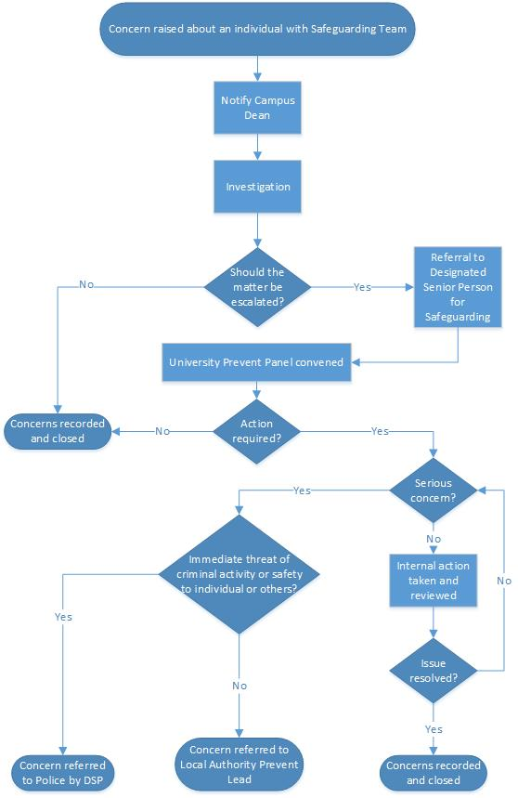
Concern referred to Police & Regional Prevent Lead by Designated Safeguard Officer
College Prevent Panel convened
Referral to Designated Safeguarding Officer
Notify
Principal
Concern raised about an individual with Prevent Team
Appendix C Referral Form
Person Subject of Referral
Date of Referral:
Name:
Date of Birth:
Place of Birth
Nationality
Ethnicity
Gender
Religion where known
Address

Local Authority
If U18 details of parents or guardian

Person Referring
Member of staff making referral
Contact details | Email
 | Phone Number
 | Address
Role
Vulnerability Factors
Factor | Notes |  |  |  | Y/N
Faith/Ideology | e.g. Concerning comments relating to faith or ideology, or association with extremists
Social Mobility | e.g. poverty, lack of education or employment, immigration issues
Physical or mental health | e.g. Disability, learning difficulties, mental health concerns
Risk or harm factor | e.g. threat posed by family member, victim of hate crime or personal attack
Criminal Activity or association | e.g. involved in criminal activity or associating with known criminals
Isolation or exclusion | e.g. lack of social activity, isolation, absent peer groups
Other factor | Any other factors  Please specify:
Is the individual aware of the referral? | Although it is not necessary or always beneficial to notify an individual, whether they are aware is important
Explanation Of Referral |  | Date last updated:
Brief explanation of reason for referral, incident details and offences.

Actions Taken To Date |  | Date last updated:

